BOND REQUEST FORM
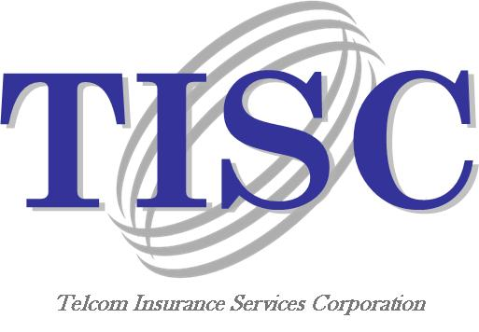
TO: Telcom Insurance Services Corp (TISC)
ATTN: Michelle Brown
Email mbrown@tiscinsagency.com
Phone 1.800.222.4664 x5131
Fax 301.474.6196

FROM:

Date Requested: |  | Bond Needed: | Bid Bond

Type of Bond Needed:
Bid Bond Performance Bond Payment Bond Other _____________________

If Bid Bond:
Bid Date: |  | Bid Time:

Obligee Name:
(Contractor is obligee)
Obligee Street Address:
Obligee City, State, Zip:
Job Name:
Job Description (Supply):
Is project a design/build?

Job Details:
Estimated Contract Price
Bid Bond Percentage
Performance Bond Percentage
Warranty Period
Completion Time
Liquidated Damages
Est Start/Complete Dates
Environmental Issues
Financing Confirmed

Estimated Contract Breakdown:
Materials (Supply Only):
Cost:
Total:

Bond Form: Obligee’s own form (attach copy)
Standard carrier bond form
Government form (attach copy or indicate form number)
AIA

